ТECHNICAL DATA SHEET

Customer: Regal Beloit Italy SpA Number: 097461
Your inquiry / project:
Our quotation number:: 557651 Pos.: 10
Contact : Steffen Schneider Phone: 07942/101-202
E-Mail : s.schneider@nicotra-gebhardt.com Fax: 07942/101-199
Process air fan |  |  |  | P2M-M6B2R-RRB
Efficiency status (single speed motors) |  |  |  | fulfills the ErP requirements 2015

Fan data in operating point: (warranty according to DIN 24166)
Offered accessory which is in contact with the transport medium can alter the characteristic curve and lead to a performance reduction
Gastype: |  |  |  |  | Atmospheric air
Air flow by inlet: |  |  |  | q_{v} |  |  | 4964 |  | m³/h
Total pressure increase |  |  |  | p_{F} | 7869 |  | 7869 |  | Pa
Static pressure increase |  |  |  | p_{sF} | 7702 |  | 7702 |  | Pa
Presure at inlet: |  |  |  | p_{a} | 101300 |  | 101300 |  | Pa
Density of media: |  | inlet |  | ρ | 1.2 |  | 1.2 |  | kg/m³
Temperature media: |  | inlet |  | T | 60 |  | 20 |  | °C
Max. allowable media temperature: |  | inlet |  | T_{max} |  |  | 60 |  | °C
Speed: |  |  |  | n |  |  | 2930 |  | 1/min
Max. allowable impeller speed: |  |  |  | n_{max} |  |  | 3600 |  | 1/min
Efficiency |  | at optimum |  | η_{opt} |  |  | 73 |  | %
Efficiency |  | at operating point |  | η |  |  | 61 |  | %
Required power |  | at fan shaft |  | P_{a} | 17.88 |  | 17.88 |  | kW
Required power |  | at motor shaft |  | P_{m} | 17.88 |  | 17.88 |  | kW
Max. required power |  | at motor shaft |  | P_{max} | 20.56 |  | 20.56 |  | kW
inertia |  | at fan shaft |  | J |  |  | 1.99 |  | kg*m²
Start-up time (note heavy restart by direct switch-on and t_{A} > 6 sec !) |  |  |  | t_{A} |  |  | 4.2 |  | sec
Sound pressure in 1 m distance, free suction |  |  |  | L_{PA5} | 95 |  | 95 |  | dB
Sound pressure in 1 m distance, casing breakout (without motor) |  |  |  | L_{PA2} | 76 |  | 76 |  | dB

Sound data according to DIN45635 part 38 (without sound attenuation equipment)

Motordata
Motor type: | Standard
Manufacturer: | Siemens |  |  |  | Type: | 1LE1503-1EA23-4FB4
Degree of protection: |  | IP55* |  |  | Mounting type: | B5
Insulation class: |  | F |  |  | Eff-/Temp.Class | IE3
Rated power: | P_{N} | 22.00 |  | kW
Rated speed: | n_{N} | 2930 |  | 1/min | Weight approx.: | G |  | 160 | kg
Frequency: | f_{N} | 50 |  | Hz
Voltage: | U_{N} | 400/690 |  | V | Sound pressure | L_{PA} |  | 73 | dB
Rated current approx.: | l_{N} | by 400 V: | 38.50 | A | Sound power | L_{WA} |  | 80 | dB

ErP-data at optimum efficiency and density 1.20 kg/m³
Measurement- / Efficiency category |  |  | B / total
Design status of VSD | without VSD
Overall efficiency (η_{opt}) |  |  | 67.7 | %
Achieved efficiency grade (N_{ist}) |  |  | 66.8
Required efficiency grade in 2013 / 2015 (N) |  |  | 61 / 64
Air flow rate (V_{opt}) |  |  | 8362 | m³/h
Pressure rise (Δ p_{opt}) |  |  | 6914 | Pa
Fan speed (n_{vopt}) |  |  | 2886 | 1/min
Motor power input (P_{1opt}) |  |  | 23.73 | kW
Specific ratio (d_{dpopt}) |  |  | 1.068

As reference for motor data we use producer Siemens – supply choose by Gebhardt and delivery possibility: Siemens, Simotop,
Marathon or AC-Motoren.
* by motors for zone 21 the degree of protection is IP 65

CHARACTERISTIC CURVE

Customer: Regal Beloit Italy SpA Number: 097461
Your inquiry / project:
Our quotation number:: 557651 Pos.: 10
Process air fan | P2M-M6B2R-RRB | Speed 2930 1/min  Density 1.2 kg/m³
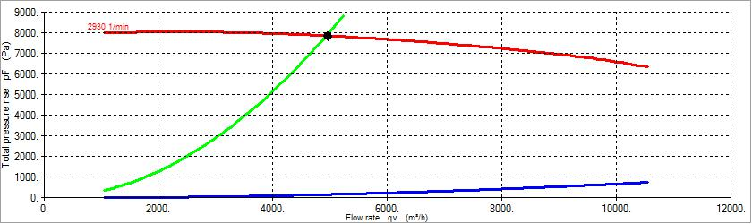

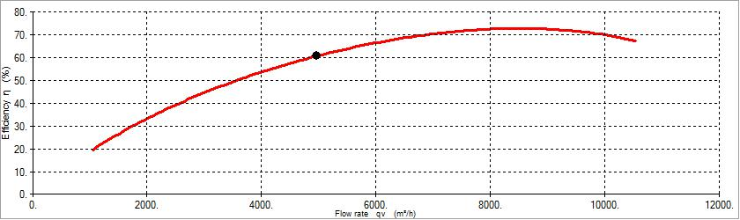

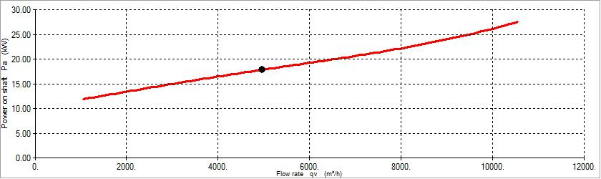

SOUND DATA

Customer: Regal Beloit Italy SpA Cust-nr: 097461
Your inquiry / project::
Our quotation number:: 557651 Pos.: 10

Process air fan P2M-M6B2R-RRB

Sound data of fan: (all data A-weighted)

 | LWA | 63 [Hz] | 125  [Hz] | 250  [Hz] | 500  [Hz] | 1000  [Hz] | 2000  [Hz] | 4000  [Hz] | 8000  [Hz] | LPA  (1m)
Casing brake trough level L_2: | 92 | 59 | 73 | 82 | 90 | 84 | 79 | 72 | 68 | 76 | dB
Level for free intake L_5: | 103 | 71 | 86 | 94 | 101 | 95 | 88 | 82 | 78 | 95 | dB
Level for free outlet L_6: | 107 | 74 | 89 | 98 | 105 | 100 | 94 | 87 | 81 | 99 | dB

DIMENSION SHEET
Customer: Regal Beloit Italy SpA Cust-nr: 097461
Your inquiry / project::
Our quotation number:: 557651 Pos.: 10

